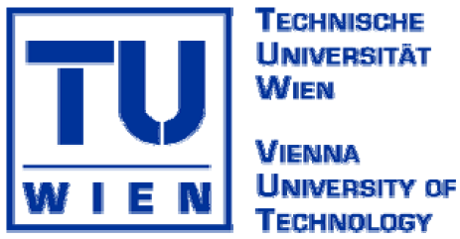

Seminar for PhD students

Research in progress on metallic materials
Bratislava (Slovakia), October 2 – 3, 2008

The main idea of the seminar is to provide a possibility for PhD students (from Austria, Czech Republic, Hungary and Slovakia) involved in the research work on metallic materials to meet each other, to inform each other about performed and planned research work and to exchange the experience with doctoral study in informal and friendly atmosphere.
The two days meeting will take place in Bratislava:
- first day (2.10.2008) in restaurant Auspic located just at the right bank side of river Danube with a beautiful view on the river, Bratislava castle and New bridge (including get-together dinner)
- second day at the Institute of Materials and Machine Mechanics of Slovak Academy of Sciences concluding with short lab tour

Preliminary programme:
Thursday, October 2, 2008
(Auspic Restaurant, Viedenská cesta 24, Bratislava):

10.30 – 11.00 a.m. Arrival to restaurant, registration

11.00 – 11.15 a.m. Opening remarks (F. Simancik IMSAS, H.P. Degischer, TUW)

11.15 a.m. – 1.45 p.m. Student’s presentations (30 min. each incl. discussion)
- Peter Henits (ELTE): Phase selection in Al-based amorphous alloys under severe plastic deformation
- Sandor Honor (ELTE): Estimation of heat production during high pressure torsion of Cu-based metallic glass
- Peter Dusan Ispanovity (ELTE): Distribution of dislocation velocities during plastic flow
- Yu Zhenzhen (ELTE): Dynamic recrystallization and grain refinement in an AZ31B Mg alloy
- Pavel Sherstnev (MUL): Analysis and computer aided optimisation of hot rolling of aluminium alloys

1.45 – 3.00 p.m. Lunch (served in restaurant Auspic)

3.00 – 6.00 p.m. Student’s presentations (30 min. each incl. discussion)
- Peter Gogola (MST): Corrosion resistance studies to austenitic stainless steels exploited for long-terms at 600, 650 and 800 °C
- Sharoz Sakhawat (TUW): "Mechanical and microstructural characterization of precipitation hardening stainless steel"
- Marian Vach (MST): Application of computational thermodynamics for prediction of secondary phase equilibria in austenitic stainless steels
- Denijel Burzic (TUW): "Oxidation and decarburisation of high Si-steels"
- Roman Pschera (MUL): Modelling of cross rolling piercing and hot rolling using Forge 2007
- Mirza Candic (MUL): Grain structure design of hot formed and annealed multi phase alloys

6.00 – 7.00 p.m. Break (accommodation arrangement in neighbouring hotel)

7.00 – 10.00 p.m. Get- together dinner (Auspic view balcony)
10.00 p.m - ?? historical city centre pubs (optionally)

Friday, October 3, 2008
(IMMM SAS, Racianska 75, Bratislava):
9.00 – 11.30 a.m. Student’s presentations (30 min. each incl. discussion)
- Reza Alavi (TUW): "Characterization of the extruded particle reinforcement tool steel"
- P. Vera (MST STU): Synthesis of manganese ferrites by mechanosynthesis
- Zuzana Gabalcova (IMSAS): Effect of solidification parameters on the structure of directionally solidified intermetallic Ti-Al alloy.
- Zahid Asghar (TUW): "Effect of Ni-intermetallics on the strength of an AlSi12 alloy".

11.30 – 12.00 a.m. 1st lunch break (small buffet at Institute)

12.00 a.m – 2.00 p.m. Student’s presentations (30 min. each incl. discussion)
- Domonkos Tolnai (ELTE+TUW): "3D characterization of AlSi8Mg5 alloy by synchrotron tomography"
- Camilo Suarez (TUW): "3D characterisation of the porosity evolution of a short fibre reinforced AlSi alloy during creep"
- Nada Frankovicova (IMSAS): High conductivity heat sinks based on high modulus carbon fibres
- Tomas Dvorak (IMSAS): Cu matrix – tungsten wire composites for high temperature heat sinks

2.00 pm –2.30 pm 2nd lunch break (small buffet at Institute)

2.30 – 3.00 pm. Presentation of IMSAS (F. Simancik)
3 pm. – 5 pm Lab tour (IMSAS research laboratories)
5 pm Closing remarks (H.P. Degischer), departure or optional guided tour to Bratislava Castle terraces

Coffee, beverages and snacks will be available during whole meeting.

IMSAS – Institute of Materials and Machine Mechanics Salovak Academy of Sciences
TUW – Technical university Vienna
MUL – Montana University Leoben
MST – Material Science and Technology school Slovak tUniversity of Technology
ELTE – Eotvos Lorand University Budapest
IMRSAS – Institute of Material Research Slovak Academy of Sciences, Kosice (presentations tbd)
A contingent of 20 rooms has been reserved in Hotel Incheba (http://www.incheba.sk/services/hotel_EN/669?lang=en), which is in walking distance from:
- Auspic restaurant (5 min)
- City Centre (10-15 min)
- Petrzalka railway station (15-20 min)

Room prices: ~ 2000 Sk double for single use, 2300 Sk double for double use,
+ 50 Sk tax per person, + breakfast 200 Sk
(1 euro ~ 30 Sk)
Free parking places are available at both Hotel Incheba and Auspic restaurant.

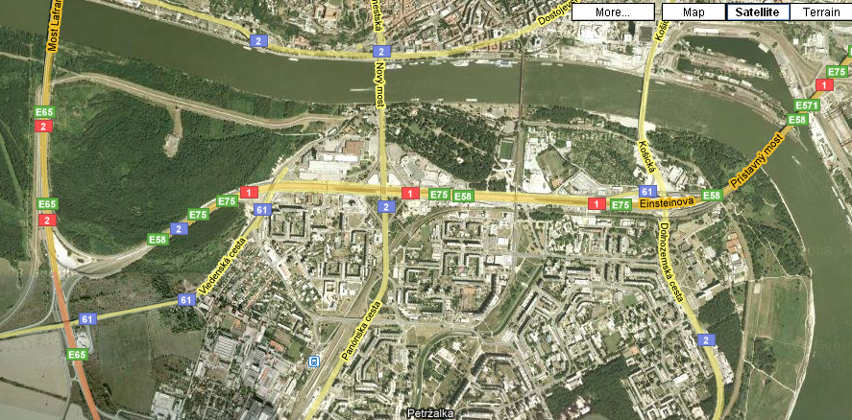

Petrzalka railway station Hotel Incheba Restaurant Auspic

Highway to Vienna & Budapest

Way to restaurant Auspic (Viedenska cesta 24):

By train:
- take train to railway station Bratislava Petrzalka, then
- walking (about 20 min) go right, then turn left along main street - Rusovska cesta and then straight forward (cross high way over the bridge, go north beside Incheba hotel towards Danube river – Auspic is located directly on the right bank of Danube river,
- taxi 5 min. (~60 Sk – 2 euro)
- bus No. 80 – two stops - Kremnicka, then 10 min walking over the highway bridge towards Danube river)

By car from highway Vienna & Budapest E65
- turn right direction Centrum, Zilina, Nitra E58, E75 or 1
- turn right direction Petrzalka Dvory, then immediately to the left, cross bridge over the highway, then straight forward to Auspic (see next picture)

In case of any difficulties please call F.Simancik +421-905-336021
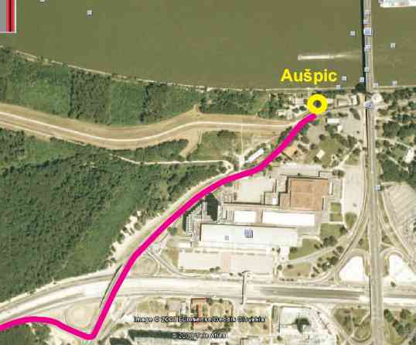

> highway highway bridge hotel Incheba

